Civics Group | Index Number | Name (use BLOCK LETTERS)  H2

ST. ANDREW’S JUNIOR COLLEGE
2021 JC2 PRELIMINARY EXAMINATION


H2 BIOLOGY 9744/04

Paper 4: Practical Exam

Tuesday 24th August 2021 2 hours 30 minutes

READ THESE INSTRUCTIONS FIRST

Write your name, civics group and index number on all the work you hand in.
Give details of the practical shift and laboratory, where appropriate, in the boxes provided.
Write in dark blue or black pen.
You may use a HB pencil for any diagram, graph or rough working.
Do not use staples, paper clips, highlighters, glue or correction fluid.

Answer all questions in in the spaces provided on the Question paper.

The use of an approved scientific calculator is expected, where appropriate. You may lose marks if you do not show your working or if you do not use appropriate units.

The number of marks is given in brackets [ ] at the end of each question or part question.

IMPORTANT INFORMATION TO CANDIDATES:

Candidates with access to microscope at the start of the paper are given the first 1h 15 min to use them. Please answer QUESTION 2 within this time frame. Once you have finished working with the microscope, you can move on to QUESTION 1.

Candidates with no access to microscope at the start of the paper should proceed with QUESTION 1 first. You will be given access to microscope at 1h 15 min after the start of the paper.

Shift
Laboratory

 | For Examiner’s Use
 | 1 | / 29
 | 2 | / 26
 | Total | / 55

This document consists of 24 printed pages.
[Turn over
Answer all questions

QUESTION 1

You are provided with a solution, labelled E, containing an enzyme Rennin which coagulates (clots) milk. Enzyme E hydrolyses (breaks) peptide bonds between certain amino acids in a protein found in milk and this results in the coagulation of the milk. Calcium ions are required for this coagulation.

When a mixture of milk, calcium chloride solution and E is gently rotated in a test-tube the
coagulation goes through the stages shown in Fig. 1.1.

Stage 3 is the end-point of the enzyme-catalysed coagulation.

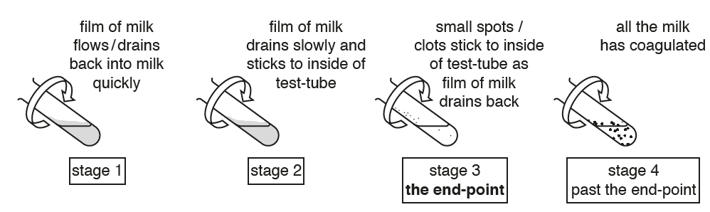
Fig. 1.1

You are required to:
- perform a simple dilution of milk solution M1
- investigate the action of E on the different concentrations of milk solution
- record the time taken to reach the end-point for each concentration of milk solution
- determine the concentration of milk in sample solution X
You are provided with:

- 10% calcium chloride solution C, in a plastic container labelled C
- 0.25% enzyme Rennin solution E, in a plastic container labelled E
- Milk solution M1, in a plastic container labelled M1
- Sample solution X, in a plastic container labelled X
- Distilled water, in a plastic container labelled DW

Solution C and E are irritants. If C or E comes into contact with your skin, wash it off immediately under tap water. Suitable eye protection should be worn.

You are required to investigate the effect of substrate concentration on this enzyme-catalysed coagulation.

(a)
(i) You are required to prepare different concentrations of milk, using M1 and DW. M1 is undiluted milk and is referred to as 100.0% milk solution.

Simple dilutions of M1 is to be carried out to obtain three other concentrations M2, M3 and M4, in which the concentration of milk solution is reduced by 25.0 % between each successive dilution. You will need to prepare 20.0 cm³ for each concentration.

Complete Table 1.1 to show how you will prepare the different concentrations of milk solution.

Table 1.1

Concentration of Milk  solution / % | Volume of M1  / cm³ | Volume of DW  / cm³
100.0 | 20.0 | 0.0

[2]

(ii) Describe a hypothesis for the expected relationship between the rate of enzyme-catalysed coagulation and milk concentration.

Assume that all other conditions are kept constant.
……...............................................................................................................................................................................................................................................................[1]
Before proceeding further:
- Use the beaker labelled Hot water to collect approximately 200cm³ of hot water from where it is provided in the laboratory.
- Use the beaker labelled Tap water to collect approximately 200cm³ of tap water from the tap.

Proceed as follows:
- Prepare the concentrations of milk as written in Table 1.1, using the small plastic containers provided.
- Use the hot and tap water to set up a water-bath in a 500ml beaker. The starting temperature of the water-bath should be between 35°C and 40°C.
You will not need to maintain this temperature from this point onwards.
- Put 5.0 cm³ of the M1 into a test-tube. Label the test-tube as 100%.
- Repeat step 3 with each of the other concentrations of milk that you have prepared and label them accordingly. Also do this for sample solution X.
- Put 0.5 cm³ of C into each test-tube.
- Gently shake each of the test-tubes to mix the milk solution and C.
- Put the test-tubes in the water-bath and leave for at least 3 minutes.

(iii) Explain why the test-tubes are left in the water-bath for at least 3 minutes in step 7.
……...............................................................................................................................................................................................................................................................[1]

- Remove the test-tube containing X from the water-bath.
The process of coagulation will start when E is added.
- Put 0.5 cm³ of E into the test-tube, so that it runs down the side of the test-tube and forms a layer on the surface of the mixture, as shown in Fig. 1.2.
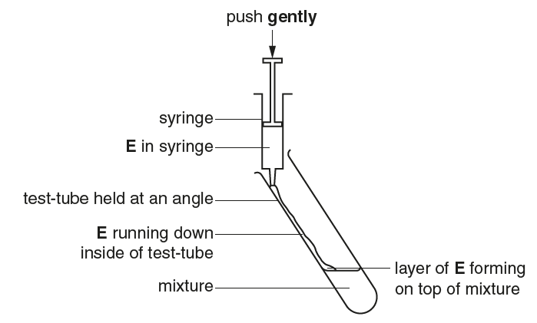
Fig. 1.2

- Gently shake the test-tube to mix the solutions and start timing.
- Hold the test-tube over a piece of black card on the table as shown in Fig. 1.3.
- Gently rotate the test-tube to form a film of milk on the inside of the test-tube.
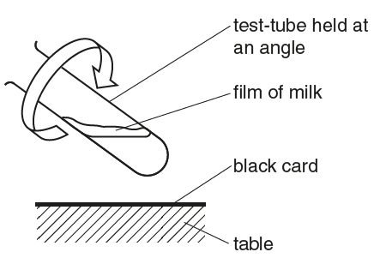
Fig. 1.3

- Observe the film and stop timing once the end-point is reached (stage 3 in Fig. 1.1). Ignore any small bubbles on the inside of the test-tube.
- Record the time taken to reach the end-point for sample X in (a)(iv).
If the end-point has not been reached in 4 minutes, stop timing and record the time taken as ‘more than 240’.
(iv) State the result for sample X.
.................... s [1]

- Repeat step 8 to step 14 with the other test-tubes labelled 100% and each of three other concentrations of milk that you have prepared in the water-bath.
Also calculate the relative rate of enzyme-catalysed coagulation and record your results for 100% and each of three other concentrations of milk that you have prepared (excluding sample X) in (a)(v).
If the time recorded is ‘more than 240’, state the relative rate of coagulation as ‘zero’.
(v) Record your results in an appropriate format in the space provided.

[4]

(vi) Complete Fig. 1.4:
- using labels to show the positions of the three other percentage concentrations of milk solution, that you have prepared by simple dilution.

- using an arrow and label of the letter X to show an estimate of the concentration of milk in the sample X, by comparing your results recorded in (a)(iv) and (a)(v).

0%
100%

Percentage concentration of milk

Fig 1.4

[2]

(vii) Replicating or repeating the investigation would increase the confidence in your estimate of the milk concentration in sample X.

Describe two other modifications to this method to obtain a more accurate estimate of the concentration of milk in the sample solution X.
……..............................................................................................................................
……..............................................................................................................................
……...............................................................................................................................................................................................................................................................[2]

(viii) One significant source of error for this investigation is the fluctuation in temperature of the manual water bath after step 2.

Complete Table 1.2 to suggest:
- How to make an improvement in reducing the fluctuation in temperature of the manual water bath after step 2.
- one other significant source of error in this procedure
- how to make an improvement to reduce this other source of error.

Table 1.2

Significant source of error | How to make an improvement
1. Temperature fluctuations occurred in the water bath after step 2.

2.

[3]

(ix) Describe a suitable control for this experiment to show that Rennin (in solution E) is an enzyme that catalyses the coagulation reaction.

Note: You do not need to carry out this control.
……...............................................................................................................................................................................................................................................................[1]

- In a different experiment, a student carried out an investigation into the effect of temperature on the activity of the enzymes in Yeast cells.

The student immobilised the yeast cells in alginate beads which were then dropped into glucose solution at different temperatures. As carbon dioxide collected in the beads they rose to the surface of the solution as shown in Fig. 1.5.

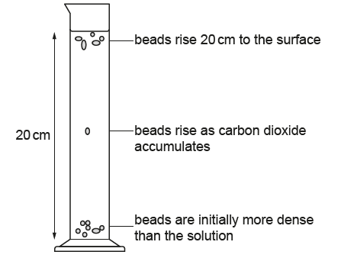

Fig. 1.5

The student measured the time taken for 5 beads to rise to the surface, a distance of 20 cm.

(i) Two variables in this investigation that were standardised were:
- The number of yeast-alginate beads used (at five per setup)
- The volume of glucose solution used to obtain a height of 20 cm

Describe how two other variables in this investigation could be standardised.
……..............................................................................................................................
……..............................................................................................................................
……...............................................................................................................................................................................................................................................................[2]

The processed results are shown in Table 1.3.

Table 1.3

temperature / °C | mean time taken for last bead to rise to the surface / s
10.0 | 72
25.0 | 19
40.0 | 11
55.0 | 36
70.0 | 108

(ii) Identify the temperature at which the beads rose the fastest: ………………..^{O}C

For this temperature, calculate the absolute rate at which these beads rose 20 cm.

Show your working.

Rate = ……………………….[2]

(iii) Use the grid provided to display the results shown in Table 1.3.



[4]

(iv) Describe and explain the shape of the graph between 40.0^{O}C and 70.0^{O}C.
……..............................................................................................................................……..............................................................................................................................……..............................................................................................................................……..............................................................................................................................
……..............................................................................................................................
……..............................................................................................................................
……...............................................................................................................................................................................................................................................................[4]

[Total: 29]
QUESTION 2

For this question, you will require access to a light microscope (with an eyepiece graticule) and the plastic container labelled M, which contains a stage micrometer.

You are provided with a leaf L, in a petri dish labelled L.

Stoma (singular) / Stomata (plural) is a structure on the surface of a leaf that modulates gas exchange between the plant and its environment. Most stomata are found on the lower surface of the leaf.
Each stoma is made of two guard cells. When these guard cells are turgid, they create an opening between them, called the stomatal pore. Gas exchange (CO₂, O₂) occurs via this pore, which is crucial for the process of photosynthesis.
In this investigation, you will indirectly view the stomata of a provided leaf specimen L under the microscope.

Proceed as follows:

- Place the leaf specimen L on a white tile, with the lower surface of the leaf facing upwards.
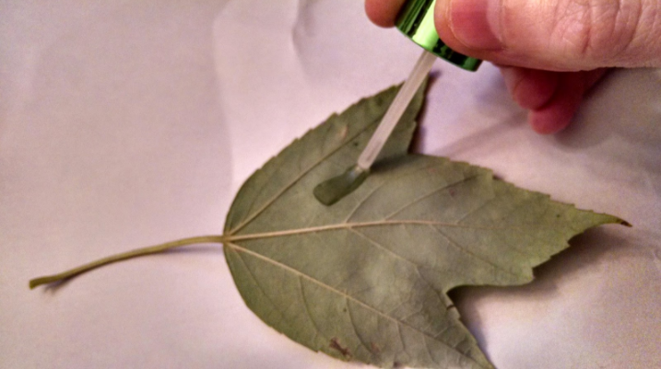
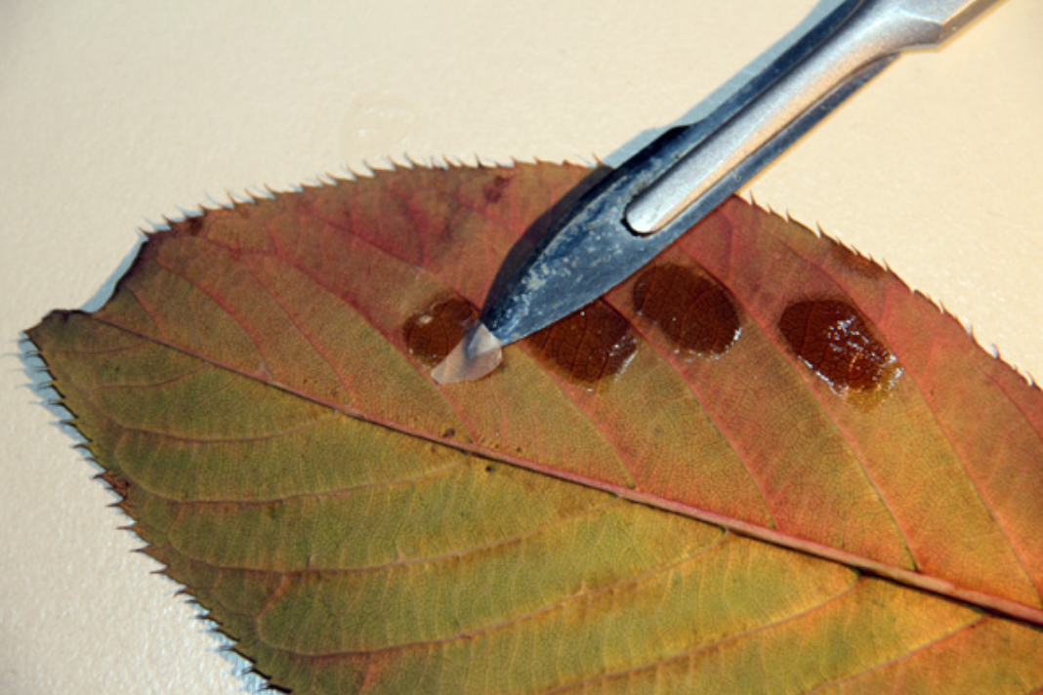
- Cover a small area (about 1 cm²) of the specimen with a thin layer of clear nail varnish. Do not cover an area with large veins.
Ref. Step 2
Ref. Step 3

Source: Photos obtained from http://phdnthesinglemom.blogspot.com/2014/10/epidermal-leaf-slides.html & http://www.microbehunter.com/using-clear-nail-polish-to-make-impressions-of-plant-leaves/
- Repeat step 2 three more times on different areas of the specimen to ensure that you have sufficient spare material if necessary.
- Put the specimen aside for at least 20 minutes, for the nail varnish to completely dry.
- During this waiting period, work through parts 2(b), 2(c) and/or 2(d), or go on to other parts of the Question paper, as appropriate.
- After the nail varnish has dried, carefully use the blade of a fine scalpel to lift one edge of the layer of nail varnish. You may then use forceps to gently peel the layer of nail varnish from the specimen. The layer is still useful even if it does not come off in one piece.
- Transfer the layer to a clean microscope slide. Gently place a cover slip on the thin layer. No water is required.

- Examine the slide using a microscope and locate an area with stomata. Then observe the stomata under high power objective lens.

Make a large drawing of one stoma with well-defined features. Surrounding epidermal cells are not to be included.

Label the stomatal pore and a guard cell.

[3]

- Did you observe the presence of chloroplasts in the guard cells when viewing the specimen under the microscope? Explain the reason for your answer.
……...............................................................................................................................................................................................................................................................[1]

You are required to measure the actual length of stoma that you have drawn in (a)(i) on the slide, under high power objective lens.

Before measuring the length of the stoma, calibration of the eyepiece graticule needs to be conducted, under 40x objective lens.

It is given that the length of each stage micrometer division is 0.01 mm.

- Conduct the actual calibration for your eyepiece graticule under 40x objective lens.

Find the actual length of one eyepiece graticule unit.

Show all your workings clearly.

Actual length of 1 eyepiece graticule unit: ..………..…… μm [1]

- Using the information found in (a)(iii), calculate the actual length of the entire stoma in your slide, under 40x objective lens.

Show all your workings clearly.

Actual length of entire stoma: ……………… μm [2]

- Using the information found in (a)(iv), calculate the magnification of your drawing of the stoma in (a)(i).

Show all the steps in your working clearly.

Magnification: .........................X [2]

- A student observed the lower epidermis of leaf of another plant species under high power objective lens of a microscope. The student did this for four different regions of the leaf. This is shown in Fig. 2.1.
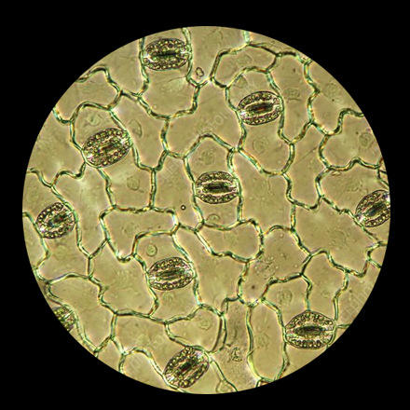 | 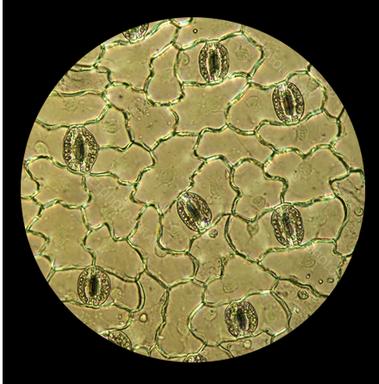
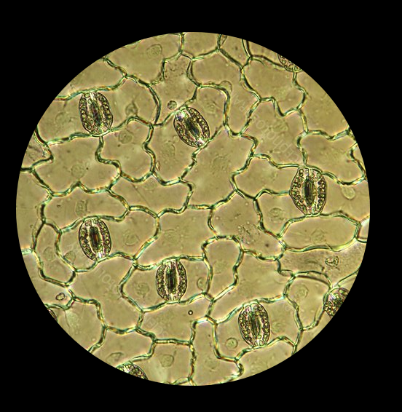 | 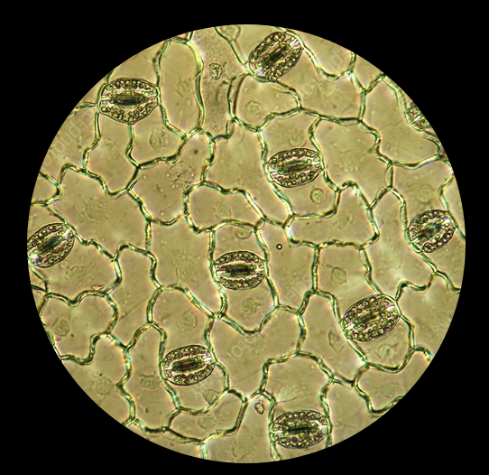
Fig. 2.1
Modified from: https://www.sciencephoto.com/media/594783/view/plantain-lily-stomata-light-micrograph

You will now determine the density of stomata on the lower surface of this leaf specimen.
- Count the number of stomata that is observed in each field of view as shown in Fig 2.1. Only include stoma for which the centre of its stomatal pore is fully visible.
Calculate the mean number of stomata per field of view.
Show your working.

Mean number of stomata in field of view = ……………………….. [2]

(ii) Under the high power objective lens, the student used a stage micrometer and found out that the diameter of the field of view is 0.45 mm, as shown in Fig. 2.2.
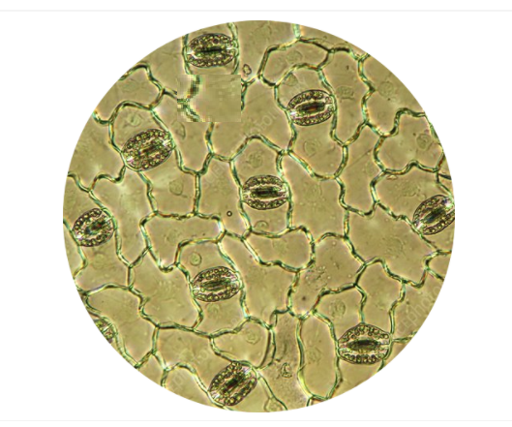
0.45 mm
Fig. 2.2

Calculate the area of the field of view and record this area in mm².
The area of a circle is given by the equation shown.

area of circle = 𝜋r²
where 𝜋 = 3.142 and r = radius of circle

Then use your result in (b)(i) to calculate the mean density of stomata per mm² for the student’s leaf specimen.

Show all your working.

Mean density of stomata for leaf specimen = ………………………mm⁻² [2]

- Fig. 2.3 is a photomicrograph of a transverse section of a plant root under 80x magnification. You are not expected to be familiar with this specimen.

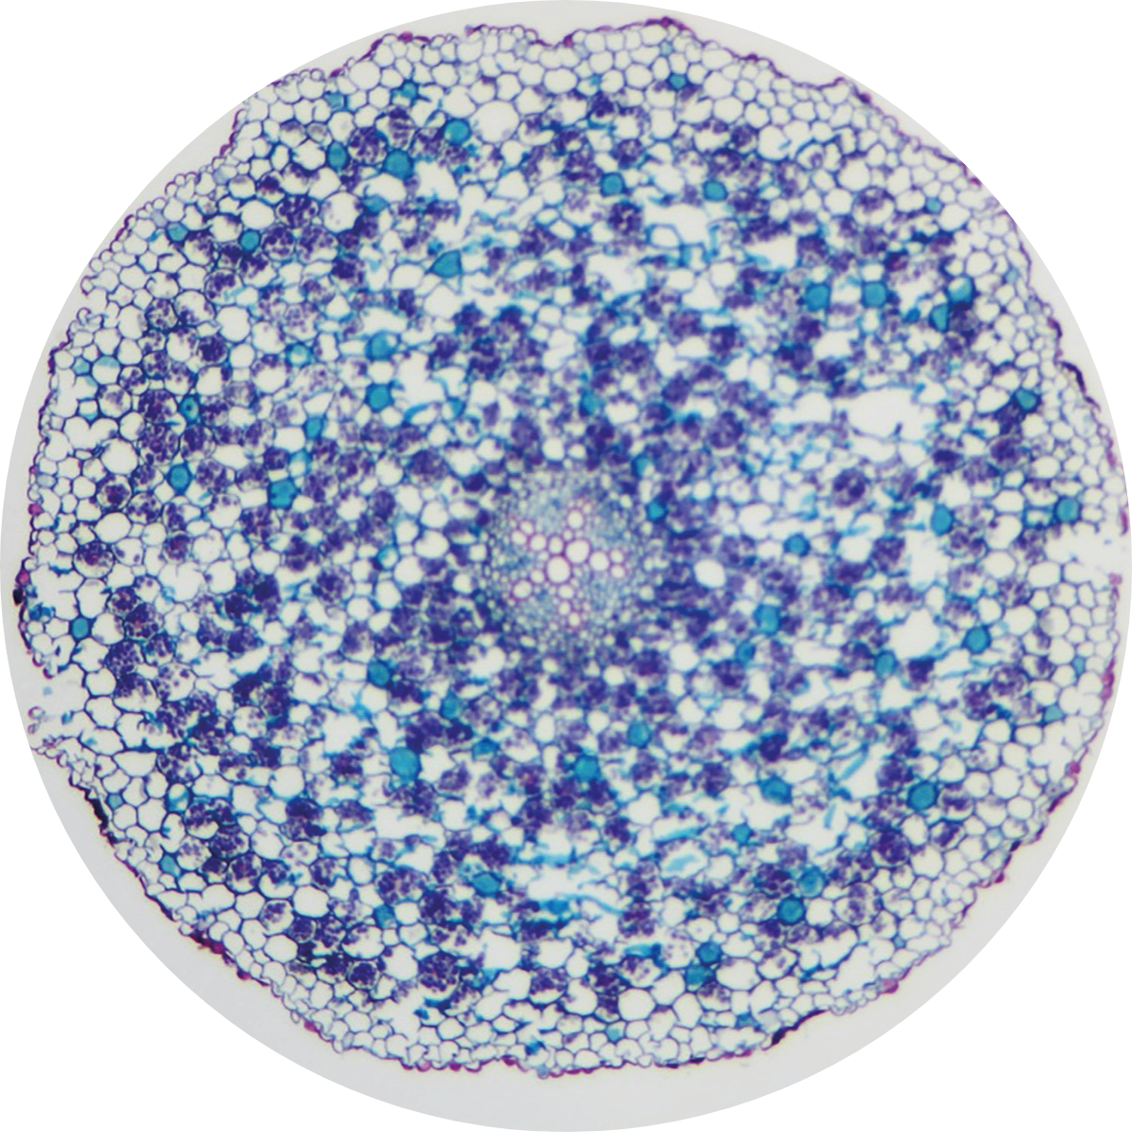
Fig. 2.3

- Draw a plan diagram of the plant root in Fig. 2.3.

A plan diagram shows the arrangement of the different tissues.
Your drawing should show the correct shape and proportion of the tissues.

No cells should be drawn. No labels are required.

[4]

- Fig. 2.4 is a photomicrograph of a stained transverse section through a root of a different type of plant.

You are not expected to be familiar with this specimen.

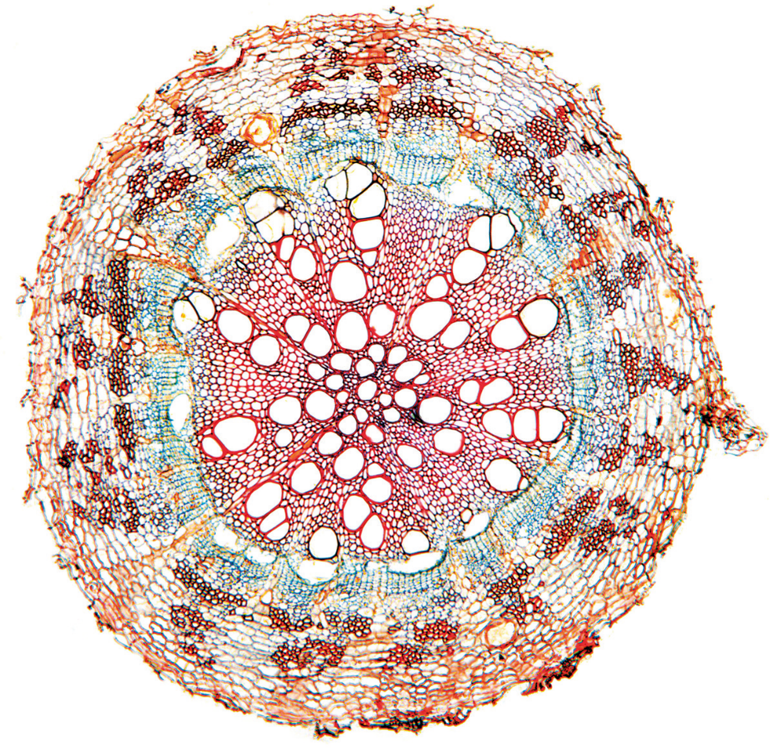

Fig. 2.4

Observe the root in Fig. 2.4 in comparison to that of Fig. 2.3.

Complete Table 2.1 to describe two observable differences between the two roots in Fig. 2.4 and Fig. 2.3 respectively.

No labels are required.

Table 2.1

Difference | Fig. 2.4 | Fig. 2.3
A

B

[2]

Invertase is an enzyme that catalysed the reaction, as shown in Fig. 2.5.
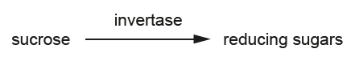
Fig. 2.5

You will plan and carry out an investigation to determine the concentration of sucrose in a sample of honey.

A student suggested the hypothesis that:

‘honey sample Z contains a sucrose concentration that is greater than 5%’.

The student carried out some preliminary experiments to find the optimum conditions for estimating the concentration of sucrose in a sample. ln the test, sucrose solution is mixed with invertase solution and, after a short incubation time, Benedict's solution is used to test a sample of the mixture for reducing sugar.

The time from starting the Benedict's test to the first colour change of Benedict's solution is recorded, up to a maximum of 180 seconds. This time provides an estimate of the concentration of sucrose. This is because the shorter the time, the higher the concentration of reducing sugar produced from the hydrolysis of sucrose by invertase. lf there is no colour change within 180 seconds of starting the Benedict's test, then it can be assumed that no reducing sugar is present.

The student found that:
- the best volumes of invertase solution and sucrose solution to use were those that gave a mixture in which sucrose solution accounted for 2/3 of the total mixture.
- hydrolysis of sucrose was most rapid at room temperature.
- the recommended incubation time for hydrolysis of sucrose in the presence of invertase was from two to five minutes.

Use the results of the preliminary tests to plan and carry out an investigation to provide results that will enable you to support or reject the student’s hypothesis.

You are provided with:
- only 10 cm³ of 5% sucrose solution, in a specimen tube labelled Y
- only 10 cm³ of a honey sample of unknown sucrose concentration, in a specimen tube labelled Z
- only 10 cm³ of 1% invertase solution, in a specimen tube labelled I.
- Benedict’s solution

For your planned method, it should:
- NOT involve the regulation of a fixed temperature using a water bath
- NOT involve the carrying out of replicates and/or repeats.
- have a clear and helpful structure so that the method described could be repeated by anyone reading it
- include details to ensure that results are as accurate and repeatable as possible
- use the correct technical and scientific terms
- only make use of the apparatus and materials provided.

You may use the space below to make any notes. Read through (d)(i), (d)(ii) and (d)(iii) before proceeding.

- Outline the steps in your method that you used to collect your results.

……..............................................................................................................................
……..............................................................................................................................
……..............................................................................................................................
……..............................................................................................................................
……..............................................................................................................................
……..............................................................................................................................
……...............................................................................................................................................................................................................................................................[3]

- Record your results in a suitable format in the space provided.

[3]

- State whether or not your results in (d)(ii) support the student’s hypothesis.

Give a reason for your answer.

……...............................................................................................................................................................................................................................................................[1]

[Total: 26]

~ END OF PAPER ~

